J3ZZ Live Solo - Tech rider (english) – CDA – QUAD LIVE
Last updated : 2023.11.03 - vibrotanica@j3zz.com

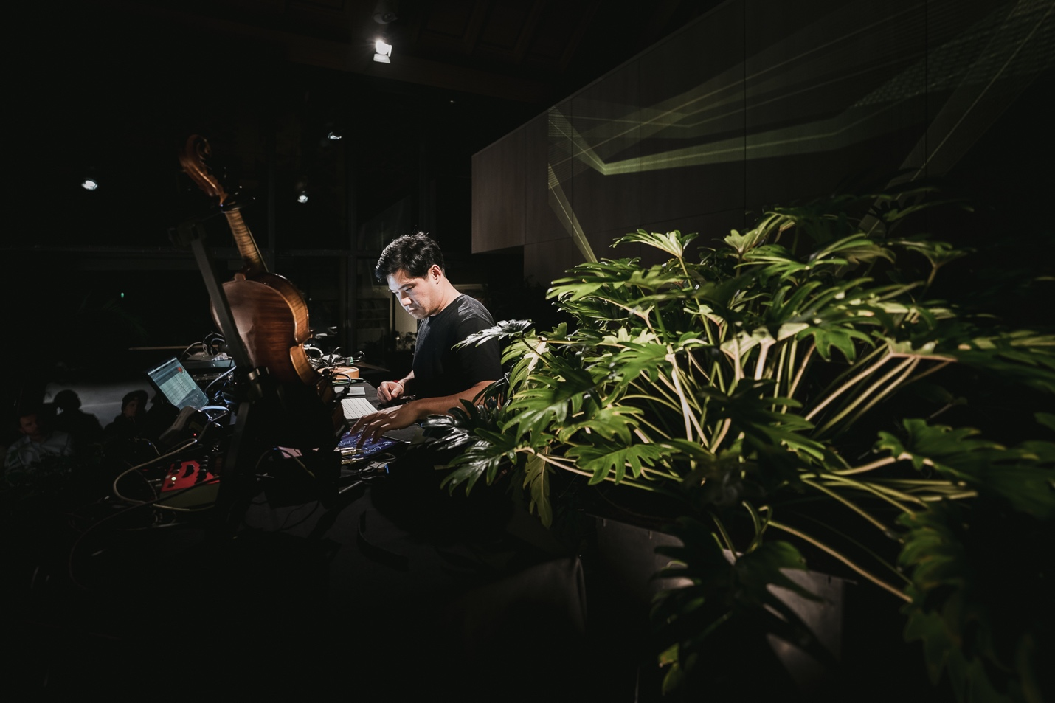
First of all, thank you for your interest in booking a show for J3ZZ Live Band. Below is a list of our technical requirements. It might sound a bit formal to you, this is not meant to cause any inconveniences on your behalf. We designed this rider for optimum effectiveness at the day of the show. If there are any questions or if you have trouble providing any of the below mentioned please get in touch with us before the day of the show and we will work out a solution.

Stage Set up

Jérôme Li-Thiao-Té - Main Artist, Mic speaker. (L) - Manager +33 (0)6 98 84 55 71.
Jérôme Ringana (on Réunion island) - Sound engineer FOH. (XL)
Aric Resnick (outside of Réunion island) - Sound engineer FOH. (XL)
The venue shall supply the following:
A high-quality audio system meeting the following requirements has to be set up and be in full working order 1 hour prior to sound check. A high-quality stereo three-way active PA system with Subs capable of providing a clear non-distorted sound with an even coverage of sound throughout the venue and capable of delivering a range between 20hz-20khz. Center fills were required, depending on the width of the stage.

Monitor System

Professional quality processed and bi-amplificated sound system.
*** * ALL MONITORS PROVIDED MUST BE OF THE SAME MODEL * ***
Two (2) Stage monitors

Digital Setup

32 x 24 Digital Monitor console (Midas ,A&H, Yamah, Soundcraft….) and all the technical requirements for the proper functioning.

(If) Analog Setup

EIGHT(8) Channels of 31 band graphic equalization (inserted not in cascade) Klark Teknik DN 360 or BSS DPR 966 Opal Drive Series

32 x 10 Monitor console (Midas, Yamaha, Soundcraft…)
ONE (1) Reverb type lexicon pcm 70
ONE (1) monitor engineer is needed for the monitor mix.

House mix (Front Of House)

Digital Setup

32 x 24 Digital FOH console (Midas, A&H, Yamaha, Soundcraft….) and all the technical requirements for the proper functioning, with USB capable recording.

Analog Setup

32 x 10 Monitor console (Midas, Yamaha, Soundcraft…) with minimum 2 Aux Sends. ONE (1) Equalizer Klark Teknik 1/3 octave - DN 360 (stereo)
ONE (1) Digital Reverb type Lexicon PCM 70
ONE (1) Digital Delay type Yamaha SPX 900
ONE (1) Digital multi effects
4 Channels Compressor / Gate type Drawner, dbx
10 Channels Compressor type DBX 160A
House technicians must be available from set-up through performance.

House Speaker System

House technicians must be available from set-up through performance.
The promoter will provide a high-quality system, multiway active, this system must produce 105 DBA at average level at the mix position.
It will have a flat response from 20Hz to 20KHz.
This system shall be in perfect working order and totally free of noise or distortion.
P.A. SYSTEM - Meyer Sound, D&B, RCF, EAW, L Acoustics, JBL, Nexo… Example: 1-500 people - 6000W, 500-800 people - 10.000W, 1000 people - 2000 people 15.000W.
The mixing desk will be placed between both sound systems and in 2/3 of the venue, NEVER under balconies and always in the same level as the audience.
If there is no area for the P.A desk, the PROMOTER will eliminate some seats in order to have this desk in a perfect position.

Microphones, cables, DI, mics, arm stands, stage flooring etc.

TEN (10) Direct Box RADIAL J48 (or Equivalent)
TWELVE (12) 6.3MM M-JACK –M-JACK CABLES
SEVEN (7) 20 M XLR CABLES
ONE (1) Shure BETA58 HF (Wireless UR Series)
ONE (1) violin stand
ONE (1) mic stand
ONE (1) white stage flooring non-reflective covering (projection will be directed to the floor)
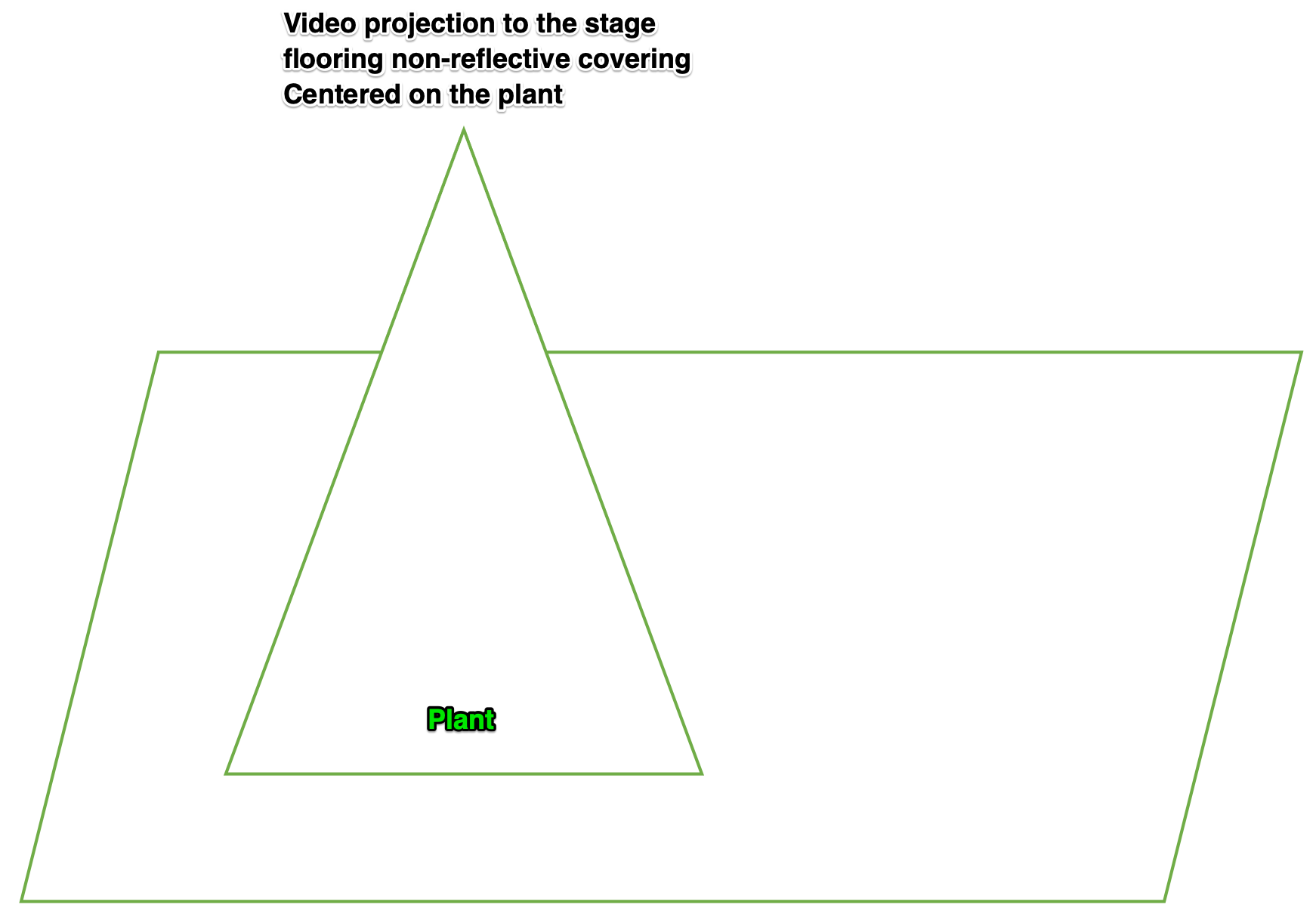

Patch List (inputs)
CH | SOURCE | MIC / DI | STAND & ACCS | BACKLINE | COMMENTS
01 | track-1 |  |  |  | To send to speaker-1 (Front-Left)
02 | track-2 |  |  |  | To send to speaker-2 (Front-Right)
03 | track-3 | DI J48 // AR 133 |  |  | To send to speaker-3 (Back-Right)
04 | track-4 | DI J48 // AR 133 |  |  | To send to speaker-4 (Back-Left)
05 | iPad-L
06 | iPad -R
07 | Vocals-L | DI J48 // AR 133
08 | Vocals-R | DI J48 // AR 133
09 | Loop-L | DI J48 // AR 133
10 | Loop-R | DI J48 // AR 133
11 | Fx-L | DI J48 // AR 133
12 | Fx-R | DI J48 // AR 133
13 | Violin | DI J48 // AR 133 | Violin stand |  | violin
14 | MoogMix | DI J48 // AR 133
15 | Bass
16 | Vocal-HF | SHURE BETA 58 HF | Mic stand
17 | Violin-dry | direct |  |  | Out of a RADIAL Tonebone PZ-PRE  Or from DPA 4099v
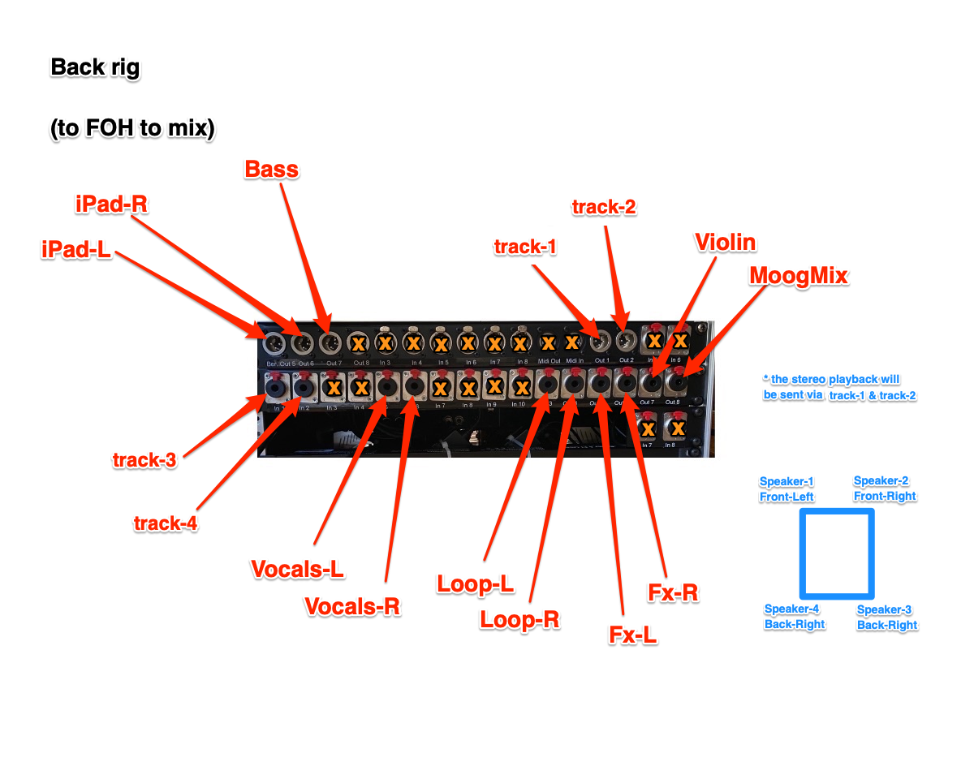

Stage plot

Power 16 amp independent circuit
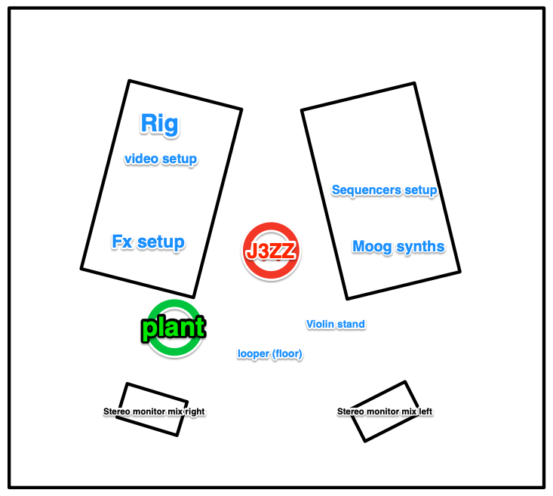

Outputs
# | description | position
01 | Speaker-1 - Main-L (Sub) | Front-Left
02 | Speaker-2 - Main-R (Sub) | Front-Right
03 | Speaker-3 | Back-Right
04 | Speaker-4 | Back-Left
05 | Stereo monitor - L J3ZZ
06 | Stereo monitor - R J3ZZ

Backline Requirements

TWO (2) BI AMPED MONITORS
TWO (2) SIDE –fill STAGE SPEAKERS
TWO (2) BACK ROOM SPEAKERS
Required lighting:
Stage lighting to be enough to cover the stage in a wash with colored filters and, or LED lighting colors tbd.
12 x moving head fixtures Robe, Clay Paky, Mac
Intelligent lighting console for Moving heads
Lighting operator for rehearsals and show
Required Projection:
12-20k lumen laser projectors
HDMI connection at stage laptop
Projection screen to accommodate room size
Artist stage needs:
Stereo Monitors L-R at artist position on stage
TWO (2) STANDING HEIGHT 90 CM tables with black covering 160-200 wide x 80cm deep
ONE (1) x 16-amp independent circuit at stage position
A sober English-speaking AV Technician who is experienced with the equipment and is to be available to assist for the duration of the artist’s visit to the venue.
All system control must be visible to our engineer if we are traveling with If not we will depend on the house staff for Sound, video, and lighting support.
Required green Plants :
The venue is required to provide ONE (1) vivid plant with unwaxed leaves for the artist to set up the vibrotanica flat surface sensors (2.5 cm x 2.5 cm) on. The leaves should be completely natural and wide enough to accommodate the sensors. The plants should be large enough to be visible to the audience, with a minimum height of 1.5 meters.

Travel, Hotel, Dressing rooms and Catering

PURCHASER agrees to provide ARTIST’S REPRESENTATIVE with detailed directions to the place of performance. If ARTIST gives advance notice to PURCHASER that the ARTIST is arriving by air, PURCHASER shall, at his sole cost and expense, provide GROUND TRANSPORTATION for ARTIST’S entourage of two (2) people, plus luggage and instruments, etc. between airport, hotel, concert, venue, and return to airport upon departure.
If PURCHASER is providing HOTEL ACCOMMODATIONS, The rooms shall be available until the day after the performance with the ARTIST to comply with checkout times and hotel rules. Rooms shall be noise free, as well as completely dark, within close proximity to the venue, and CONTAIN BALCONIES and/or WINDOWS THAT OPEN.
PURCHASER shall provide one (1)+ comfortable and private DRESSING ROOM. This room must be clean, dry, well-lit, heated or air-conditioned, shall contain at least chairs and shall be within easy access to clean and private lavatories which are supplied with soap, toilet tissue and plenty of clean towels (minimum 2). Towels shall be provided for ARTIST’S use in dressing rooms and on stage. A professional steamer (preferred) {or iron with ironing board} is required in band dressing room.
PURCHASER shall guarantee adequate SECURITY at all times to insure the safety of the ARTIST’S personal instruments and personal property from the beginning of load-in to completion of load-out. During soundcheck, performance, and after show, PURCHASER will have security backstage, on-stage, and at the mixing console. PURCHASER is held responsible for the personal belongings and for all equipment of the ARTIST.
HOSPITALITY: PURCHASER shall provide refreshments in quantities sufficient for two (2) persons, available from bands arrival until departure.
A good supply of Coffee with and without caffeine, Tea Water, and Soft drinks should be available at this time. mineral waters, beers, dried fruits, sugar, lemon, and honey should be provided, with spoons and an ashtray.
CHECK and remain available through company load out Menu Suggestions: Fish or Chicken with Rice and Vegetables, additional vegetable side dish, fresh bread and butter etc. ** No deep-fried or “fast” food please.**
PURCHASER shall also provide the name and address of a good quality restaurant for after the performance, restaurant should be at open between 11pm and midnight.

